CYNGOR CYMUNED PENNARD
PENNARD COMMUNITY COUNCIL

Clerk – Mrs. Jan Crocker
11 Anderson Lane, Southgate, Swansea, SA3 2BX
Tel 07825 225567 or 01792 293924
email: pennardcommunitycouncil@gmail.com
www.pennardcc.org.uk

To: MEMBERS OF PENNARD COMMUNITY COUNCIL/CYNGOR CYMUNED PENNARD
Members are summoned to attend a meeting of the ENVIRONMENT COMMITTEE OF PENNARD COMMUNITY COUNCIL VIA ZOOM on 21st May at 7.00pm. (Press & Public are invited to attend via Zoom contact Clerk for passcode)

Under the Public Bodies (Admission to Meetings) Act 1960 (S.1 (7) filming and recording of meetings by the press and the public is not permitted.

Join Zoom Meeting
https://us02web.zoom.us/j/82100848232
AGENDA
Apologies for absence
Schedule 12 of the Local Government Act 1972 requires a record to be kept of the members present and that this record form part of the minutes of the meeting. Members who cannot attend a meeting should tender apologies to the Clerk as it is usual for the grounds upon which apologies are tendered also to be recorded. Under Section 85(1) of the Local Government Act1972, members present must decide whether the reason(s) for a member's absence are accepted.

Declarations of interest
All votes will be named votes
Questions from the Public relating to items on this agenda (limited to 10 minutes)

- To meet with Footpaths Officer (Bishopston) to discuss Walkers are Welcome and footpaths in Pennard, agreeing any action if required.
- To discuss and agree the purchase of a tree and where it should be planted to commemorate the Community Council anniversary.
- To discuss the agree a plan to deal with the invasive bamboo at the park in line with our biodiversity plan.
- To discuss the problems occurring at the Castle and other Golf Club owned areas and agree a way forward.
- To discuss the problems faced at Kittle Green and agree a response.
- To discuss Swansea Council’s spaying regime and agree a way forward.
- Discuss next steps for bee friendly status – set up a working group
- To discuss funding bid for summer playscheme provision and agree to fund the scheme should the bid be unsuccessful.

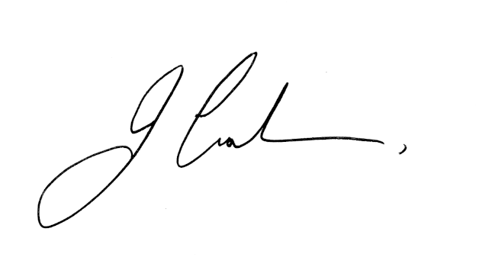
Jan Crocker PSLCC
Clerk 15 May 2024

