

CYNGOR CYMUNED PENNARD
PENNARD COMMUNITY COUNCIL

Clerk – Mrs. Jan Crocker
11 Anderson Lane, Southgate, Swansea, SA3 2BX
Tel 07825 225567 or 01792 293924
email: pennardcommunitycouncil@gmail.com
www.pennardcc.org.uk

To: MEMBERS OF PENNARD COMMUNITY COUNCIL/CYNGOR CYMUNED PENNARD

In accordance with the Local Government and Elections (Wales) Act 2021, you are hereby summoned to attend a meeting of PENNARD COMMUNITY COUNCIL PLANNING COMMITTEE to be held on Wed the 28th Jan 2026 at 7.00pm, remotely Via Zoom.
(Press & Public are invited to attend via Zoom)

To Join Via Zoom
https://us02web.zoom.us/j/86745245873

AGENDA
Apologies for Absence
Declarations of Interest
Questions from the Public (limited to 10 minutes)

- Planning Applications out for Consultation.

2026/0016/FUL - 49 Linkside Drive, Southgate, Swansea, SA3 2BR
Proposal: Single storey side and rear extension and front and rear rooflights

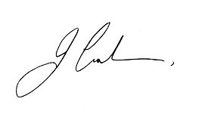

Jan Crocker PSLCC
Clerk
23 Jan 26

